ARTICLE TITLE IN THE LANGUAGE OF THE ARTICLE [12 pt, Bold, Center, ALL CAPS]

Article author's name, surname [11 pt, Bold, Center]
Institution represented by the author of the article [11 pt, Itallic, Center]

Annotation in the language of the article [10 pt, Bold]
The text of the article annotation should not exceed 600 characters (about 100 words) [10 pt, Justify, First line: 1,27 cm]. This is concise one paragraph text about the work performed, presenting the purpose of the research, its logical justification, the research methods applied and the main conclusions and / or the new questions raised.
KEY WORDS [10 pt, Bold]. Indicated 3-5 key words of the article, separated by commas [10 pt, Justify, First line: 1,27 cm].

Introduction [11 pt, Bold]
The text of the introduction is written from a new line. In the introduction relevance of the topic as a scientific problem is justified, the object of the research, the aim of the article, tasks and methods used, the article's structure is presented. [11 pt, Justify, First line: 1,27 cm]

Title of the chapter [11 pt, Bold]
The text of the chapter is written from a new line. In the main part of the article the theoretical justification of the work is presented, the results of the research are discussed. The main article text is written in Times New Roman font [11 pt, Justify, First line: 1,27 cm] In the text mentioning the author is necessary to provide references to the list of literature, which is written in the following order: in brackets is recorded source author's name without name, after comma - year of publication, after the colon - page or page numbers, for example: (Petraitis, 2007: 41). Listing multiple sources at once they are seperated by semicolons, for example: Some scientists (Jonaitis, 2003: 131-132; Petraitis, 2004: 86) did not approve that ...

Figures, charts and schemes
Figures, chart or scheme is inserted in the text as part of the text in the new blank paragraph in which it is centered. Figures and chart must be clear and legible, not be too large or too small. Schemes and drawings - grouped into a common object. Title is written in the center under the figures, 11 pt, Bold, it is necessary to specify the source. Figures are numbered in numerical order in Arabic numerals, the abbreviation "Fig." is used. After the name of the figures, the dot is not written. References to figures and tables are written in brackets indicating their markings, for example: (Table 1) or (Fig. 2).

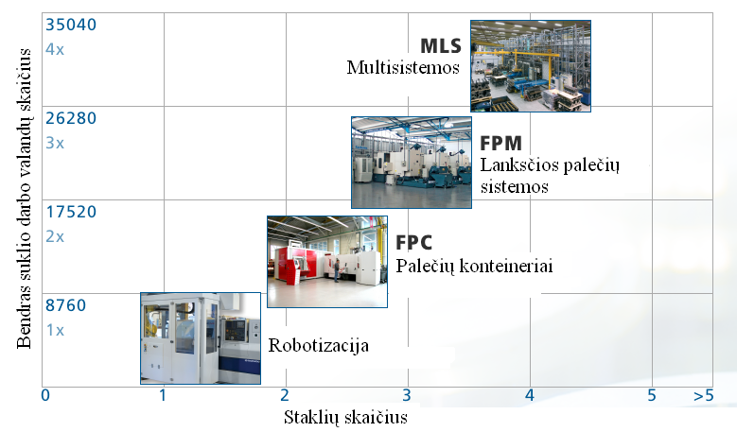
Fig. 1 [11 pt, Bold] Title of the figure
Source: compiled by author [10 pt, Italic]

Tables
The table in the text is inserted as part of the text in the new blank paragraph in which it is centered. Tables are numbered in numerical order in Arabic numerals, using the word "Table", which is aligned to the right of the page margin. Title and source must be specified. Table titles are written in 11 pt, Bold above the table and centered. After the title of the table dot is not written (Table 1).

Table 1
Title of the table [11 pt, Bold]
Medžiaga | Sritis | Panaudojimas
Keramika (aliuminio oksidas, cirkonio oksidas, silicio karbidas, magnio oksidas) | Automobilių pramonė | Stabdžių diskai, variklių blokavimo detalės
 | Medicininė technika | Klubų sąnariai, dantų protezai, implantai
 | Aviacija | Sandarinimo ir izoliaciniai elementai
Source: Sudhakar M. New Developments in High-Speed Machining Technology//Moldmaking Technology (2007). Prieiga per internetą: <www.moldmakingtechnology.com>[10 pt, Italic]

The data size in the table is 8-10 pt according to the information provided. In the tables, the first lines of the paragraphs are not separated from the edge.

Mathematical formulas
Mathematical formulas or other mathematical expressions are inserted in the text in a separate new paragraph. Formulas are written using the Microsoft Equation 3.0 formula editor. The formulas are numbered sequentially in Arabic numerals in brackets. Numbered on the right side of the formula. For example:
$τ=\frac{2(S_{1}−S_{2})}{n(n−1)}$, (1)
where τ - Kendall coefficient, S₁ - the higher rank of the elements of the item being ranked, S₂ - the smaller rank of elements for the element in question, n - the number of ranks.

Conclusions
The conclusions of the article are presented, which must be numbered in Arabic numerals.

Literature [11 pt, Bold]
The sources in the list of references are listed in the Latin alphabet according to the names of the authors, and if not, according to the first letter of the publication. Sources are written in non-Latin characters, are listed at the end of the list. Each source is marked by a sequence number. If several publications of the same author published in the same year are indicated, they are distinguished by the letters a, b, c ... after the year of publication. The edition of the publication is indicated if the source is quoted or indicated publication is not the first one. The translator is indicated when there are several translations of the same work. Sources are numbered sequentially in Arabic numerals. [10 pt]

ARTICLE TITLE IN FOREIGN LANGUAGE [10 pt, Centered, Bold]

Summary [10 pt, Bold]
Summary of the article in other than article writing language. The text should contain about 200 words [10 pt, Justify, First line: 1,27 cm].

A COVER LETTER OF AUTHORS

Author name, surname: First name, Family name.
Science degree and name: doctor, associated professor.
Workplace and position: X University Of Applied Sciences, X faculty X depatment associated professor.
Author‘s research interests: manufacturing technologies, material technologies, methodology of engineering sciences.
Telephone and e-mail address: 8 6xx xxxxx, zzzz@delfi.lt

Article layout
The recommended size of the articles - 3-5 A4 size sheets. The article must be followed by the following requirements:
- The text is written in Microsoft Word as a text editor, in Times New Roman, single space between lines, 11 pt Normal style.
- Paragraph indent - 1.27 cm.
- The text of the article, tables and illustrations uses the SI unit system.
- Margins of the document: 2 cm at the top and the bottom, 2 cm on the left and 2 cm on the right.
- Pages are not numbered.

